DAY 6 -> 18-05-2026
Project 1: Customer Churn Prediction & Lifetime Value (LTV) Engine
EDA -> Dataset Profiling & Data Understanding
DONE BY -> ANANTHARAJAN V B
Missing Value Validation & Dataset Cleaning Continuation

- Rechecking Missing Values After NaN Replacement

Description:
This method is used to revalidate the dataset after replacing hidden blank spaces with NaN values. It helps identify columns that still contain missing values and ensures the previous cleaning steps were successfully applied before proceeding with further preprocessing operations.

FORMULA USED -> filepath.isnull().sum()
OUTPUT
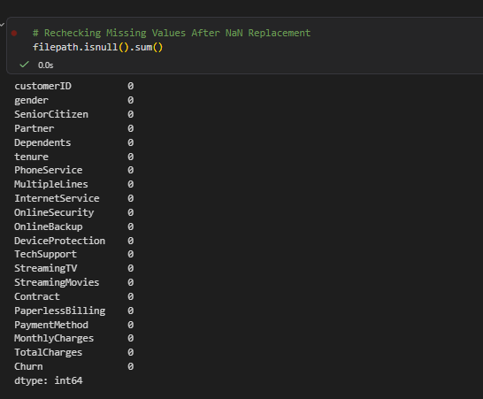

- Datatype Consistency Validation

Description:
This method is used to inspect and validate the datatype of each feature in the dataset. Some numerical columns may be incorrectly stored as object datatype due to hidden spaces or invalid values. Datatype validation ensures all columns are stored in their appropriate format for accurate preprocessing and model training.
FORMULA USED -> filepath.dtypes
SCREENSHOT
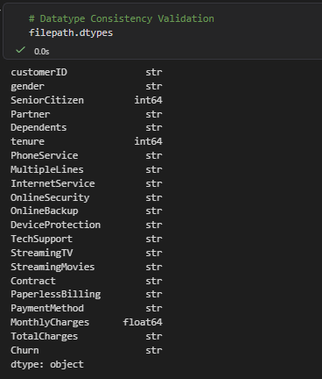

3) Converting Incorrect Numerical Datatypes
Description:
This method is used to convert incorrectly stored numerical columns into proper numeric datatype. The conversion process replaces invalid entries with NaN values using error handling techniques, allowing missing values to be treated correctly during preprocessing.
FORMULA USED -> #filepath['TotalCharges'] = pd.to_numeric(filepath['TotalCharges'], errors='coerce')

SCREENSHOT

- Identifying Columns Requiring Imputation

Description:
This method is used to identify columns that still contain missing values after datatype conversion and validation. It helps determine which features require imputation and supports the selection of suitable null-handling strategies for different data types.

FORMULA USED -> filepath.isnull().sum()[filepath.isnull().sum() > 0]

SCREENSHOT
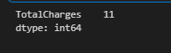

- Separating Numerical and Categorical Features

Description:
This method is used to separate numerical and categorical columns based on their datatypes. Feature separation is important because numerical and categorical variables require different preprocessing and missing value treatment techniques during data cleaning.
NUMERICAL
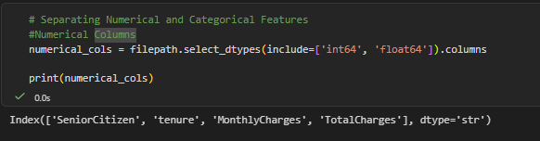
CATEGORICAL
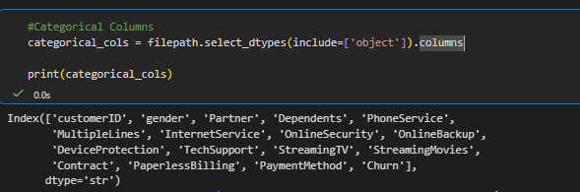

- Numerical Null Value Treatment

Description:
This method is used to handle missing values present in numerical columns by replacing them with the median value of the respective feature. Median imputation is preferred because it reduces the influence of outliers and preserves the overall distribution of numerical data.

FORMULA USED for col in numerical_cols:
filepath[col] = filepath[col].fillna(filepath[col].median())
SCREENSHOT
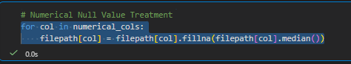

- Categorical Null Value Treatment

Description:
This method is used to handle missing values present in categorical columns by replacing them with the mode value of the respective feature. Mode imputation helps maintain the most frequently occurring category and preserves categorical data consistency.
FORMULA USED -> for col in categorical_cols:
filepath[col] = filepath[col].fillna(filepath[col].mode()[0])

SCREENSHOT
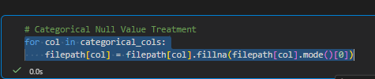

8) Final Missing Value Validation
Description:
This method is used to perform a final validation of the dataset after all missing value treatments have been completed. It ensures that the dataset no longer contains null values and confirms that the data cleaning process was successfully executed before creating the cleaned dataset version.
FORMULA USED-> filepath.isnull().sum()
SCREENSHOT
